Mrs. Kurtz's Third -Fourth Grade Book Projects

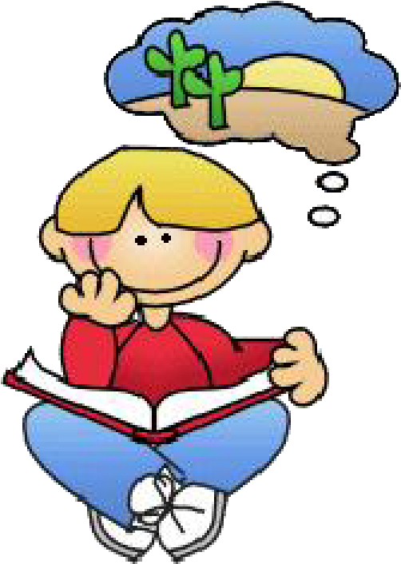
It's time to put your reading comprehension skills to work. This year, you will be expected to read and do projects for six books. It is up to you to select the books and projects you will share with the class. A different project must be chosen for each book. Your books must come from different genres each month: realistic fiction, non-fiction, historical fiction, science fiction, biography, mystery, fairy tales, fables, myths, and fantasy.

Here are the directions and requirements for each book project:

- From the choices listed, choose six ways to share your books. Every project must be different. Each book and method of sharing must be approved before beginning a project. A planning sheet (attached to the end of this packet) will keep you on track for your projects. All books and project ideas must have teacher approval before you start working.

- One book project is due on the last school day of each month from September through March (no project in December). You cannot do more than one project in a month.
- Every projects consists of three elements:
  - Sharing your project with the class.
  - Giving an oral summary of the book (2-3 minutes). Please practice at home so you know what you are going to say for your oral presentation.
  - Participating in a short discussion of how your project was completed.

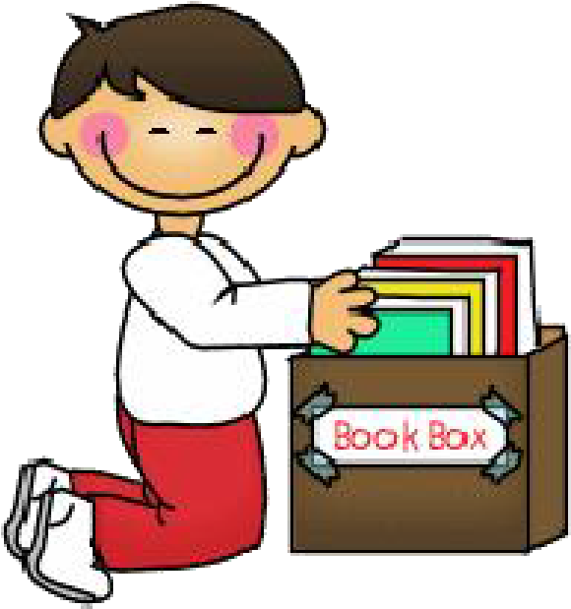
- Book projects will be completed at home. You may use books from the classroom or from home. Please save this packet so you can refer to the directions as you are working. Any changes to your project (book or project idea) must be approved.

Book Project Choices

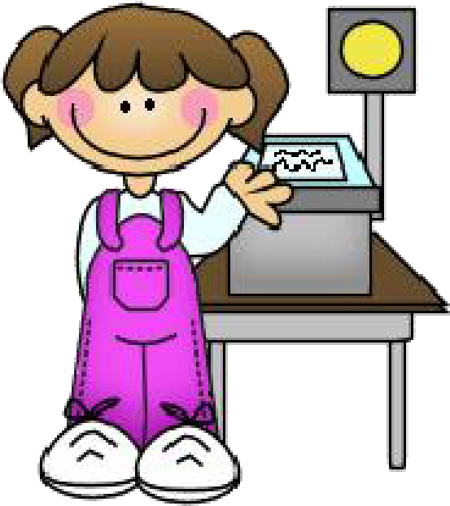
- Written Book Report

- Crossword Puzzle (Across and Down)

- Board Game

- Shoe Box Diorama (Model)

- Lights, Camera, Action!

- Hanging Mobile

- Mystery Person: Who Am I?

- Book Jacket

- TV Commercial

- Clay Models

- Ten Important Questions

- It's All About Me

1. WRITTEN BOOK REPORT

- Write the title of the book on the top line and underline it. Skip a line and write the author under the title.
- Skip a line. Write a summary paragraph about the book. Be sure your paragraph has a main idea.
- Write additional paragraphs about the main events that happen in the book in the order that they happened. Include details that support your topic sentences.
- Write a paragraph about your reaction to the book. The paragraph should be written so the book sounds interesting enough for someone else to read.
- Make a cover page for your report. It should include the title, author, your name, the date, and an illustration.
- This report can be written or typed.

- Be prepared to give an oral summary of the book. Be familiar with the characters, setting, problem and solution.

2. CROSSWORD PUZZLE ( Across and Down)

- Make a list of 20 key words that remind you of your book.

- Get graph paper from the classroom or print it off the computer. Then write the words on the graph paper making a crossword design. Use all capital letters when you write the words.
- Outline each word in the puzzle by drawing a line on top of the graph paper line around each word. Use a ruler to make your lines straight. This is your answer sheet.
- Number the words going across first. Write the number of the word in the upper left corner of the first letter of the word. Next, number the words going down. If the number for the first letter of the word going down is already there, keep that number. If there is no number already in the box, give the word a new number.
- On a separate piece of paper, list the clues for the words ACROSS. Use the number in the box of the first letter in the word in the puzzle for the clue for that word.
- List the clues for the words DOWN. Be sure the numbers of the clues match the words in the puzzle.
- Copy the outline of the puzzle on another sheet of graph paper. Use a ruler to draw the lines. Add the numbers in the upper left corner of the box. DOUBLE CHECK FOR
ACCURACY! This is the blank puzzle that will be solved.
- Write a title for the puzzle. It should be the title of your book.
- Write your name and book title on the top of each sheet--the clues, the blank puzzle, and the answer sheet.
- Be prepared to give an oral summary of the book. Be familiar with the characters, setting, problem and solution.

3. BOARD GAME
- Create a board game using the characters and setting from the story you read.
- Use buttons or other small items for the markers.

- Use a spinner or dice for the number of spaces the pieces move.
- Draw the board on heavy paper. Make the pieces move through places or events from the story.
- You may need to make up question and answer cards to go with the game.

- Include a set of rules, the game board, and the game pieces in a baggie. Be sure your name and the name of the game are on the board and on the baggie.
- Be prepared to give an oral summary of the book. Be familiar with the characters, setting, problem and solution.
4. SHOE BOX DIORAMA (model)

- Trace the bottom of a shoe box on a plain piece of paper. Cut out the shape. Make sure it fits into the bottom of the shoe box. Draw and color the background or setting of the scene on this paper. Glue it in the shoe box.
- Draw, color, and cut out characters. Attach L-shaped strips of heavy paper to the back of each character. Glue each character to the bottom of the box. Do this for any other props you would like to add to make your scene realistic.
- Be prepared to give an oral summary of the book. Be familiar with the characters, setting, problem and solution.
5. LIGHTS, CAMERA, ACTION!
- Choose an event from your book that would be fun and interesting to act out. If more than one character appears in the scene, have classmates who have read the same book take the other parts.
- Dress up and use props to act out the action of the story. Practice several times so everyone knows what to do. You may use cards to help you remember your parts.
- Be prepared to give an oral summary of the book. Be familiar with the characters, setting, problem and solution.

6. HANGING MOBILE

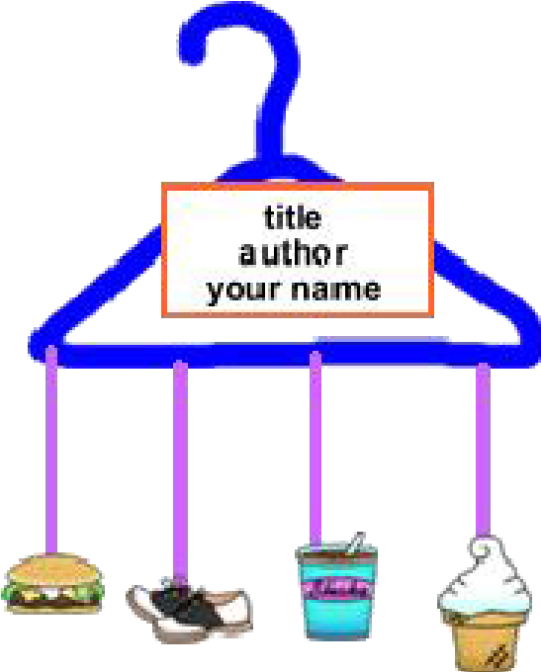
- On a sheet of paper, brainstorm a list of the most important (1.) characters in your book, (2.) the settings, and (3.) any special objects that were part of the story. For instance, in
"Charlotte's Web", Fern, Wilbur, and Charlotte are important characters. The Arable's barn and the County Fair are settings.
Objects that are important are Wilbur's crate and the words
Charlotte writes.
- After listing all the possible characters, settings, and objects you can think of, decide which ones best represent your book. Choose 5-7 to illustrate, drawing both the front and back views. Your items should be colored on both sides. Make them medium size, not too small and not too large... just right.
- Hang the items from pieces of yarn or string on a hanger.

- Add a card with the book title, author and your name.
- Once you have tied the pieces to the mobile and have each piece balanced, place a drop of glue on the string so it doesn't slip on the hanger.
- Carry your mobile to school in a trash bag or other large bag. Paper clip the card parts together so they don't tangle. We will hang it when you get to class.
- Be prepared to give an oral summary of the book. Be familiar with the characters, setting, problem and solution.

7. MYSTERY PERSON: Who Am I?

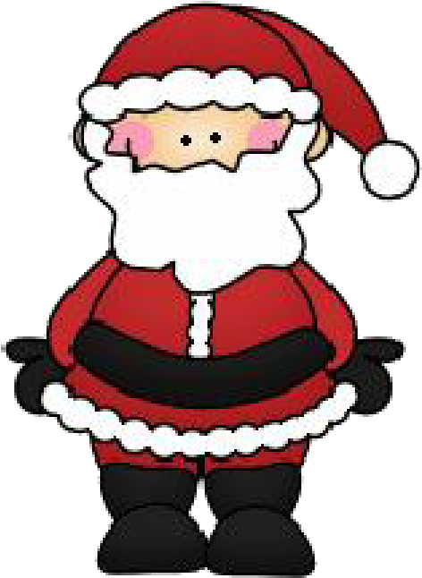
  - This project is good for a biography or a book that nearly everyone in the class knows.
  - Choose a character from your book that is well-known to your classmates.
  - Write ten clues about your well-known mystery person on index cards. Your clues should summarize the person's whole life.
  - When you present your mystery person, you can dress up and act
out clues OR read the clues that tell us about your past and who you are.
  - Your classmates will make guesses about who you are so please make sure you give clues about you and your life.

8. BOOK JACKET
- For this project use a 12' X 18" piece of construction paper.

- Fold the paper in half. Then fold each end of the paper in 3
1/2 inches to make the inside flaps of the book jacket.
- On the front cover, write the title and the author of your book. Draw and color a picture that is appropriate for your
book. Book Jacket by: _
- On the front inside flap, write a summary of the story in your own words. Include what kind of book this is, who the main characters are, the setting, and the main events of the story.
- On the back inside flap, write a short paragraph about the author. You should include where the author lives, the author's interests, and other good books written by this author.
- On the back cover, write a short blurb that will catch a reader's attention.

- Be prepared to give an oral summary of the book. Be familiar with the characters, setting, problem and solution.

9. T V COMMERCIAL

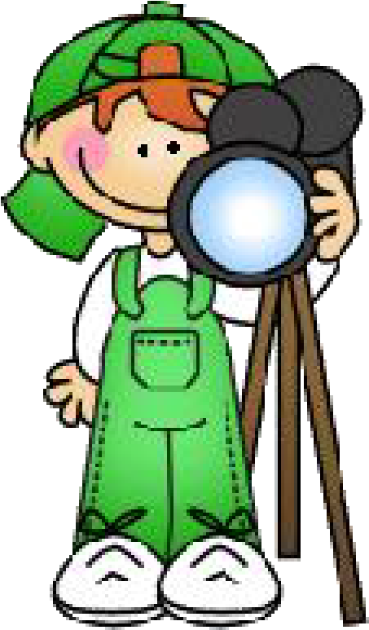
  - Decide what the best thing is about your book.

  - Write a commercial promoting your book. Be sure to tell why this book is such a good selection, but don't give away the ending. The commercial should not last more than a minute. You can have up to three other people in your commercial with you.
  - Turn in your script with the title of the book, the author, and your name on it.
  - Be prepared to give an oral summary of the book. Be familiar with the characters, setting, problem and solution.
10. CLAY MODELS

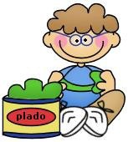
  - Choose at least two figures or objects that represent your book to make out of clay.
  - You may use any kind of clay--plasticene, modeling clay, or flour and salt play dough. You can color the clay or paint the figures after they dry.
  - On a 4" X 6" card, write the title of the book (underlined) on the top line. On the next line, write the author's name. Skip a
line. Write a paragraph telling about the figure you made. Tell something that happened to this figure in the story you read.
  - Write your name at the bottom of the card. It will be on display with your project.

  - Be prepared to give an oral summary of the book. Be familiar with the characters, setting, problem and solution.

11. TEN IMPORTANT QUESTIONS

- Write ten questions you think anyone who reads your book should be able to answer. They can be true/false, multiple choice, or short answer questions that require some writing. Your questions should be from the beginning, middle, and end of the book. Remember to use what, where, how, when, who, and why in your questions.
- Write the title of your book at the top of your question page.

- Put the answers on another sheet of paper.

- Make sure your name and book title are on both sheets.

- This project can be typed or written.
- Be prepared to give an oral summary of the book. Be familiar with the characters, setting, problem and solution.

12. IT'S ALL ABOUT ME

- Gather 7 to 10 items that the main character might put in a "Me Bag".

- Before you put the items in a bag, decorate the bag with the title of the book, the author's name, and your name. Draw pictures or designs that relate to the story.
- Introduce the main character of the book to the class by explaining why that character would choose each of the items in the bag.
- Be prepared to give an oral summary of the book. Be familiar with the characters, setting, problem and solution.

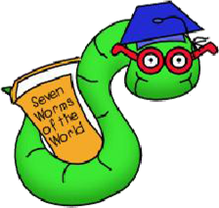

Book Genres

Mystery: The characters are usually fictional but they behave in realistic ways. There is a problem that needs to be solved. A mystery may have a detective or a spy as a main character. Clues are used by characters to find a solution to the mystery.

Biographies: A biography is a book of true stories about the life of a real person. The author is a different person than the book is written about. The person in the biography can be dead or alive. The author describes how the person affected others.

Fantasy: A fantasy is a fictional story where there is a struggle between good and evil, and often involves magic. The characters or objects do things that couldn't happen in real life. Creatures may be in the story that don't exist in life.

Fables: Fables are short stories with animal characters that act like humans. There is a lesson or moral to be learned from each story.

Myths: Myths take place before people were on earth. They try to explain things.

Realistic Fiction: The characters in these stories behave in realistic ways.

Historical Fiction: Some characters may be real and others are fictional. The story takes place during a period in history. Real events from history are mixed with fictional events.

Science Fiction: These stories are written with future ideas such as space travel and new technology. The characters are fictional. A problem is usually solved using science.

Non- fiction: Non-fiction books provide true facts and information about different subjects.

Fairy Tales: The characters in fairy tales are make believe. Fairy tales may involve magic. They often begin with "Once upon a time" and end with "they lived happily ever after."

Name: _ _

Book Projects

- Witten Book Report | - Mystery Person: Who am I?
- Crossword Puzzle (Across and Down) | - Book Jacket
- Board Game | - TV Commercial
- Shoe Box Diorama (Model) | - Clay Models
- Lights, Camera, Action! | - Ten Important Questions
- Hanging Mobile | - It’s All About Me

 | Book title | project # | genre # | teacher approval | Presentation  Notes
Sept. | 1.
Oct. | 2.
Nov. | 3.
Jan. | 4.
Feb. | 5.
Mar. | 6.

GENRES:
1. mystery | 2. biography | 3. fantasy | 4. non-fiction | 5. fairy tales
6. realistic fiction | 7. historical fiction | 8. fables | 9. science fiction | 10. myths

