I-pad Drive

Help us continue to lead our students into the forefront of technology by completing class sets of 25-30 iPads. The Ryan Academy students and faculty are excited about taking another step forward in our journey of 21st century learning. Currently we have a high speed computer lab that is used for research and learning, but bringing iPads into the classrooms will give each student and teacher the ability to open their minds and imaginations through dynamic and adaptive learning. By obtaining iPads we can allow the students to create their own videos and use more updated educational apps than the rest of the classrooms are able to use.

You may make a donation at

https://fundly.com/ryan-academy-of-norfolk-s-ipad-drive-2015-1

Facebook

Please join the Ryan Academy Facebook Page for the latest news.

Please Save the following:

Box Tops for Education

Campbell’s Soup Labels

Farm Fresh Receipts

Deposit labels and receipts in boxes located near the Building Blocks office or the box in front of the library.

IOWA/ITBS Test

We will be administering standardized testing during the week of April 20-24. Please do not make any appointments for your child that week. The Iowa Assessments provide detailed information about your child in a variety of important content areas including Reading, English Language Arts, Mathematics, Science and Social Studies.

2015-2016 Registration

For those that have not already registered, registration contracts will be sent home April 13th. Take advantage of the discounted registration fee for April. Please sign and return one copy of the contract to reserve your child’s place in next year’s class.

Spanish

Our Spanish teacher will be on maternity leave beginning April 1st. The students will have a hip-hop dance clinic once a week for the last 8 weeks of school.

Independent Projects

All grade levels will be working on their Independent projects during the next several weeks. Grades K-2 will be completing projects about animals. Grades 3-5 will be completing projects about subjects of their choice. Projects will be presented April 20-24.

## Upcoming Events

March 26- Report Cards

March 27-Zoo

April 3-10- Spring Break

April 13-April 17- Week of the Child

April 20-24- IP presentations

April 24- Academic Fair

May 8- Awards Ceremony/ Mother’s Day Tea

May 25- No School

Respect, Responsibility, Resourcefulness

March 23, 2015

Volume 1, Issue 5

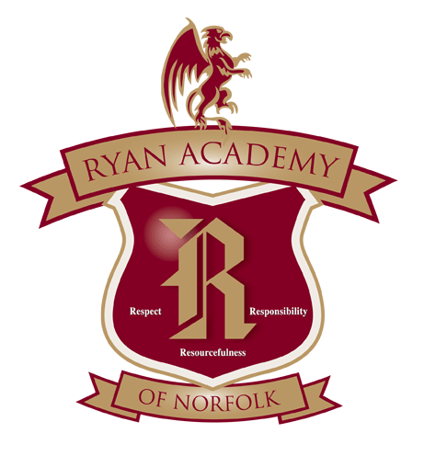

**Ryan Academy**

844 Jerome Ave

Norfolk, VA 23518

**Phone:**

(757) 583-7926

**E-mail:**

www.ryanacademy.org

Griffin Gazette