Menu |  | - 2017  - May
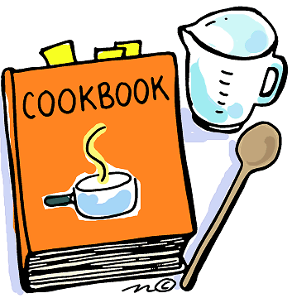  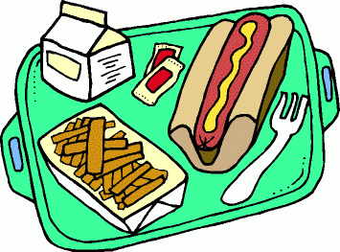  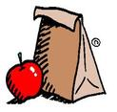 |  | MONDAY  Sausage Biscuits, Tater Tots, Oranges & Milk  TUESDAY  Bologna with Cheese, Pickles, Cantaloupe & Milk  WEDNESDAY  Chicken Nuggets, Mashed Potatoes, Bananas & Milk  THURSDAY  Corn Dogs, Broccoli, Watermelon & Milk  FRIDAY  Pack-a-Lunch- $5.00 charge for forgotten lunch

