Ryan Academy Reopening Plan

COVID-19 Response Team: Lisa Lee, Shannon Kurtz, Ramona Richards

*Classroom learning is the heart of why we’re together at Ryan Academy. Ryan Academy has five small multi-level classrooms for grades kindergarten, first/second, third/fourth, fifth/sixth, and seventh/eighth. Our plan is to accommodate and encourage social distancing in learning spaces, taking advantage of Ryan’s already small class sizes, large campus and our available classroom spaces.* *We are working to adjust layouts within classrooms, identify and relocate some classes to larger rooms, and possibly even repurpose some spaces like the gym that aren’t typically used as classrooms.*

*We are also making plans to use technology in order to provide flexibility should students need to miss class for health reasons. Having these tools in place will also allow for continuity of instruction if public health considerations warrant additional steps – for example a short suspension of in-person classes for increased cleaning and testing.*

*Professional development opportunities for faculty are currently being offered this summer, and more are being planned. Students will also have resources and support for engaging in different types of teaching and learning.*

*Resources will be available to ensure that students who have symptoms of an illness or have been quarantined can be absent physically from the class but maintain progress with their work.*

*In line with state guidance, Ryan’s policy regarding face coverings is to encourage them, and to ask any faculty, staff or students, when appropriate, to wear them when social distancing is not possible.*

Addressing Gaps in Learning

Measuring and Responding to COVID-19 Learning Loss

Teachers will meet together to talk about what parts of the 2019-20 curriculum they were able to cover during the shift to distance learning, and what they ended up leaving out, due to pacing problems or difficulty teaching that content through distance learning. The point is to get to a consensus about what, in general, students did not get a sufficient opportunity to learn.

Then, the teachers will examine the next year’s curriculum, weave in these missing foundational pieces, and alter the scope and sequence of lessons and units to match.

In August there will be teacher training on formative diagnostic assessment- how to develop and make use of day-by-day and minute-to-minute gauges of what students know that help them alter teaching in real time. Formative diagnostic assessment is the process of questioning, testing, or demonstration used to identify how a student is learning, where his strengths and weaknesses lie, and potential strategies to improve that learning. It focuses on individual growth.

This will allow teachers to immediately diagnose problems in students’ understanding or gaps in skills, and to help teachers decide next steps in instruction. Some strategies that are used are self-evaluation and metacognition, analyzing work of varying qualities, writing laboratory or other reflective journals, peer review, rubrics and oral questions, and observation protocols designed to identify specific problem areas or misconceptions in learning the concept or performing the skill.

 We are going to continue our focus on current grade level, and use intervention time and home time to address individual learning gaps. While some reteaching will occur, the key issue will be what skills and competencies students need to take the next level and progress through all the courses. As teachers identify foundational skills and content students need help with, they will supply parents with information and ask them to focus on those skills at home. That would free up teachers to spend most of their time on the grade-level curriculum.

Teachers will be provided with resources to share with students and outlining common reactions to stress and recommendations for supporting children that are broken down by age group.

Method of Instruction Plan

Phase 1

While in Phase 1, teachers deliver lessons through online videoconferencing in Teams, in real-time instruction. Teachers will combine real-time lessons with related asynchronous learning activities to deliver high quality instruction within a predictable schedule of regular class meetings.

For example, a student will be expected to "attend" his or her regularly scheduled classes from 8:30 a.m. to 11:00 a.m. Monday through Friday, via Teams. Outside of the Teams classes, the students will have additional work that they must complete and turn into their teachers, just as they normally would do. And resources, such as art, physical education, and foreign language continue in this format.

Phase 1 Schedule

|  |  |
| --- | --- |
| 8:30 a.m.-10:15 a.m. | Digital learning through Teams, including group activities, core course instruction and individual assignment completion. |
| 10:30 a.m.- 11:00 a.m. | Specials: K-4: Mon: Language, Tues: Art, Wed: PE, Thurs: Art, Fri: Language  5-8: Mon: Art, Tues: Language, Wed: PE, Thurs: Language, Fri: Art |
| 11:00 a.m. - 12:00 p.m. | Lunch and Break |
| 12:00 p.m. - 3:00 p.m. | Outside time, nap time, play time, reading time, asynchronous or independent practice- Virtual conferences available by appointment |

PDF copies of the worksheets will also be available on the website. Printed copies can be provided for any student that requires it and be picked up weekly from the office. Links to all the e-textbooks will be available online.

Phase 2

**Grades K-4** -Teachers will conduct in person learning with social distancing in place. All desks will face forward with maximum possible distance between each desk. No more than 12 people per classroom.

* Physical distancing of at least 6 feet will be maintained to the greatest extent possible in all buildings.
* Limited communal supplies, each student will maintain their own supplies box and any shared supplies will be cleaned between each student use.
* No sharing of spaces, such as specials classrooms or gymnasium. Teachers will transition, not students.
* No fieldtrips.
* Limit nonessential visitors.
* No mixing of class groups – each class will have recess individually and eat lunch in the classroom.
* Face coverings will be encouraged but not required for students, though strongly encouraged for older students, and they will be required for faculty and staff when they cannot socially distance.
* Daily health screenings of students and staff or any parents entering the building for drop off or pick up (Questions and temperature check)
* Stagger arrival dismissal times.
* Frequent handwashing required, and sanitation stations provided at each exit/entrance.
* Web cameras will be placed in classrooms to allow students that are quarantined to have access to instruction and provide continuity of learning.

**Grades 5-8**- Teachers combine real-time lessons with related asynchronous learning activities to deliver high quality instruction within a predictable schedule of regular class meetings. ***See Addendum***

Phase 2 Schedule

|  |  |
| --- | --- |
| 8:30 a.m.-10:15 a.m. | Digital learning through Teams, including group activities, core course instruction and individual assignment completion. |
| 10:30 a.m.- 11:00 a.m. | Specials: 5-8: Mon: Art, Tues: Language, Wed: PE, Thurs: Language, Fri: Art |
| 11:00 a.m. - 12:00 p.m. | Lunch and Break |
| 12:00 p.m. - 3:00 p.m. | Outside time, nap time, play time, reading time, asynchronous or independent practice- Virtual conferences available by appointment |

Phase 3

All students will return to school and teachers will provide in person instruction. All desks will face forward with maximum possible distance between each desk. No more than 16 people per classroom.

* Physical distancing of at least 6 feet will be maintained to the greatest extent possible in all buildings.
* Limited communal supplies, each student will maintain their own supplies box and any shared supplies will be cleaned between each student use.
* No sharing of spaces, such as specials classrooms or gymnasium, attendance will be staggered.
* One-way routes will be created in the hallways for transitions and dismissal.
* No off-campus fieldtrips.
* Limit nonessential visitors.
* No mixing of class groups – each class will have recess individually and eat lunch in the classroom.
* Face coverings will be encouraged but not required for students, though strongly encouraged for older students, and they will be required for faculty and staff who cannot socially distance.
* Daily health screenings of anyone entering the building for drop off or pick up (Questions and temperature check)
* Frequent handwashing required, and sanitation stations provided at each exit/entrance.
* Web cameras will be placed in classrooms to allow students that are quarantined to have access to instruction and provide continuity of learning.

Communication Plan

* Weekly updates will provide information on the following as needed:
  + School closures (i.e., whether the school will close, duration of school closure, rationale behind closure)
  + Continued instruction/enrichment or a rationale for the lack thereof. It will define current expectations for both students and teachers.
  + Medication retrieval
  + Disinfection procedures
  + CDC and VHD recommendations
* A centralized page on the school website will have all COVID-19 updates and relevant resources so they are easy for families to find.
* Information about dismissal decisions and the possible COVID-19 exposure will be communicated to families by email and text alerts.
* Notices will be placed on the website and Facebook.
* If there is a positive case of COVID-19 in the school, families will be notified however we will maintain confidentiality of the student or staff member as required by the Americans with Disabilities Act and the Family Education Rights and Privacy Act.

Cleaning Plan

Staff and others should clean hands often, including immediately after removing gloves and after contact with an ill person, by washing hands with soap and water for 20 seconds. If soap and water are not available and hands are not visibly dirty, an alcohol-based hand sanitizer that contains at least 60% alcohol may be used. However, if hands are visibly dirty, always wash hands with soap and water.

* We will wear disposable gloves to clean and disinfect.
* We will clean visibly dirty surfaces usingsoap and water, then use EPA-approved disinfectant on high touch surfaces.
* We will practice routine cleaning and disinfection of high contact areas and hard surfaces, including doorknobs/handles, desks/chairs, light switches, and restrooms at least daily or between use as much as possible.
* We will clean shared equipment such as the printer, pencil sharpener and keyboards with disinfecting wipes before/after each use.
* The use of shared objects (e.g., physical education equipment, art supplies, toys, games) will be limited when possible, and cleaned between each use.
* We will ensure ventilation systems operate properly and increase circulation of outdoor air as much as possible, by opening windows and doors when safe and appropriate.
* Soft and porous materials, such as area rugs and seating, will be removed and stored to reduce the challenges of cleaning and disinfecting them.
* Ensure that water systems and features are safe to use after any prolonged facility shutdown.

Health Plan

**Staying Home when Appropriate**

* Students and staff who become sick at school or arrive at school sick are sent home as soon as possible.
* Sick students and staff, particularly those with symptoms of respiratory illness, will be kept separate from well students and staff in the office area until they can leave.
* Staff will educate families about when they/their child(ren) should stay home and when they can return to school.

o Sick students and staff members should not return to work until they are fever and symptom free.

o Employees and students who have recently had close contact with a person with COVID-19 will be

required to stay home, maintain social distancing, and self-monitor until 14 days from the last date of

exposure. There will be no perfect attendance awards.

o Employees and students will be required to stay home if they have tested positive for or are showing

COVID-19 symptoms until they have met the criteria to discontinue home isolation.

**Hand Hygiene and Respiratory Etiquette**

* Staff will teach and reinforce handwashing with soap and water for at least 20 seconds especially after going to the bathroom; before eating; and after blowing your nose, coughing, or sneezing and increase monitoring to ensure adherence among students and staff.
* If soap and water are not readily available, hand sanitizer that contains at least 60% alcohol can be used.
* Staff and students should always wash hands when they are visibly soiled and after removing a facemask.
* We will encourage staff and students to cover coughs and sneezes with a tissue. Used tissues should be thrown in the trash and hands washed immediately with soap and water for at least 20 seconds.
* If soap and water are not readily available, hand sanitizer that contains at least 60% alcohol can be used.
* We will post signs in highly visible locations (e.g., school entrances, restrooms) that promote everyday protective measures and describe how to stop the spread of germs (such as by properly washing hands).
* Instructions will be posted at each handwashing and/or hand sanitizing station.
* Disinfecting wipes will be put at all high touch places (e.g. Printer, Computer lab, Supply Cabinet) to be used before and after items have been used.

**Cloth Face Coverings**

* Staff will teach and reinforce use of cloth face coverings. Face coverings should be worn by staff and students (particularly older students) as feasible and are most essential in times when physical distancing is difficult.
* Individuals will be frequently reminded not to touch the face covering and to wash their hands frequently.
* Information will be provided to staff, students, and students’ families on proper use, removal, and washing of cloth face coverings.

**Adequate Supplies**

* Adequate supplies will be provided, including soap, hand sanitizer with at least 60 percent alcohol, paper towels, tissues, and disinfectant wipes.
* Students will be discouraged from sharing items that are difficult to clean or disinfect.
* Each child’s belongings will be kept separated from others’ and in individually labeled containers, cubbies, or areas.
* We will ensure adequate supplies to minimize sharing of high touch materials to the extent possible or limit use of supplies and equipment by one group of children at a time and clean and disinfect between use.
* We will avoid sharing electronic devices, toys, books, and other games or learning aids.
* PPE masks will be available for those that do not have them.

**Illness**

* If there is a substantial increase in the number of students or staff missing school due to illness, it will be reported to the Norfolk Health Dept. (757) 683-2800.
* Students and staff who become sick at school or who arrive at school sick will be sent home as soon as possible.
* We will keep anyone sick separated from well students and staff in the office “sick area” until the sick person can be sent home.
* If a student or staff is diagnosed with COVID-19 we will immediately notify the Norfolk Health Dept. (757) 683-2800. These officials will help us determine a course of action for our school to close or limit in person instruction.
* Cleaning staff will clean and disinfect all areas (e.g., classrooms, bathrooms, and common areas) used by the ill persons, focusing especially on frequently touched surfaces.
* If school is temporarily dismissed, (after cleaning and disinfection), school will stay open for staff members (unless ill) while students stay home. This will allow teachers to develop and deliver lessons and materials remotely, thus maintaining continuity of teaching and learning; and allows other staff members to continue to provide services and help with additional response efforts.

Arranging Instructional Spaces

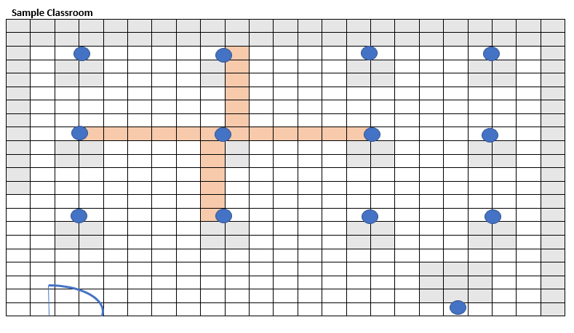

 Classrooms will have six feet of distance between desks to the greatest extent possible and desks will all be turned to face the same direction.

**Rooms Available to spread out as needed**:

Library Art/Language room

Gym Cafeteria

After school Room 1 After school Room 2

Outdoor Classroom Area

Teachers will need to pare down extra furniture and other items in their classrooms—like bookshelves, rugs, and comfortable seating—to accommodate more student space.

Teachers will assign supplies to a single child or allow one group of children to use the supplies at a time, disinfecting between every use.

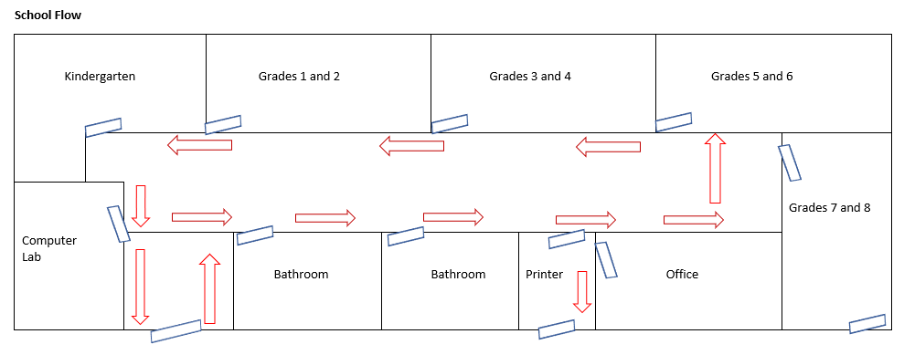

5th/6th & 7th/8th

Entrance/Exit

3rd/4th

Entrance/Exit

V

K & 1st/2nd

Entrance/Exit

Students will enter/exit through different doors and only be permitted to go to lockers at arrival and dismissal. Lunches will be kept and eaten in classrooms.

|  |  |
| --- | --- |
| **Staggered Arrival:**  Kindergarten: 9:00 a.m. (8:35 a.m.)  Grades 1 and 2: 8:15 a.m.  Grades 3 and 4: 8:20 a.m.  Grades 5 and 6: 8:25 a.m.  Grades 7 and 8: 8:30 a.m. |  |

Lockers will be assigned to allow social distancing. Grades 5-8 will be assigned alternating lockers on the upper tier and grades 1-4 will be assigned alternating lockers on the lower tier. Only one class will be permitted at the lockers at a time, so this will allow distance between the students while at the lockers.

|  |  |  |  |  |  |
| --- | --- | --- | --- | --- | --- |
| Upper Tier | Grades 5/6 | Grades 7/8 | Grades 5/6 | Grades 7/8 | Grades 5/6 |
| Lower Tier | Grades 1/2 | Grades 3/4 | Grades 1/2 | Grades 3/4 | Grades 1/2 |

***Addendum 8/05/2020- Due to the small numbers in our classrooms, middle school students will now be permitted to remain in face-to-face instruction during Phase 2.***

Phase 2

**Grades 5-8** -Teachers will conduct in person learning with social distancing in place. All desks will face forward with maximum possible distance between each desk. No more than 12 people per classroom.

* Physical distancing of at least 6 feet will be maintained to the greatest extent possible in all buildings.
* Limited communal supplies, each student will maintain their own supplies box and any shared supplies will be cleaned between each student use.
* No sharing of spaces, such as specials classrooms or gymnasium. Teachers will transition, not students.
* No fieldtrips.
* Limit nonessential visitors.
* No mixing of class groups – each class will have recess individually and eat lunch in the classroom.
* Face coverings will be encouraged but not required for students, though strongly encouraged for older students, and they will be required for faculty and staff when they cannot socially distance.
* Daily health screenings of students and staff or any parents entering the building for drop off or pick up (Questions and temperature check)
* Stagger arrival dismissal times.
* Frequent handwashing required, and sanitation stations provided at each exit/entrance.
* Web cameras will be placed in classrooms to allow students that are quarantined to have access to instruction and provide continuity of learning.