ADMISSION

We appreciate your interest in Ryan Academy of Norfolk. You're welcome to pick up a complete application packet at our school, or contact us and we'll mail one to you.
Admission Procedure
1. School Visit
Please attend an Open House or School Tour. It's a great way to see the school and meet our teachers. We will also arrange a private tour if you are unable to attend scheduled events.
2. Application and Fee
Submit a completed Application for Enrollment along with a $100 Application Fee (nonrefundable).
Please submit your completed application to: Ryan Academy of Norfolk, 844 Jerome Avenue, Norfolk, VA 23518. Applications may be faxed to 757-587-9183, or e-mailed to skurtz@ryanacademy.org.
3. Admission Decision
Once this process has been completed and a decision about the applicant’s admission is made, the parents or guardians will be notified by phone and in writing. Ryan Academy of Norfolk reserves the right to make a final admissions decision at any point in this process if it is determined that we may not be able to meet a child's or family's needs.
Ryan Academy of Norfolk admits students of any race, color, creed, and national or ethnic origin.
4. Agreement to Enroll
If your child is invited to join Ryan Academy of Norfolk, your prompt acceptance will be important. Upon agreeing to enroll your child, pertinent forms, including an Enrollment Contract, will need to be completed and applicable fees will be due.
Visiting Ryan Academy
While our website or pamphlet can give you a sense of our community, philosophy, and culture, nothing can replace a visit to our campus. We invite you to attend one of our Admissions events or email our office to schedule an individual appointment. We look forward to seeing you!
Turning Today’s Learners Into Tomorrow’s Leaders
Ryan Academy
of Norfolk
844 Jerome Ave
Norfolk, VA 23518
Phone (757) 583-7926
www.ryanacademy.org

RESPECT, RESPONSIBILITY AND RESOURCEFULNESS
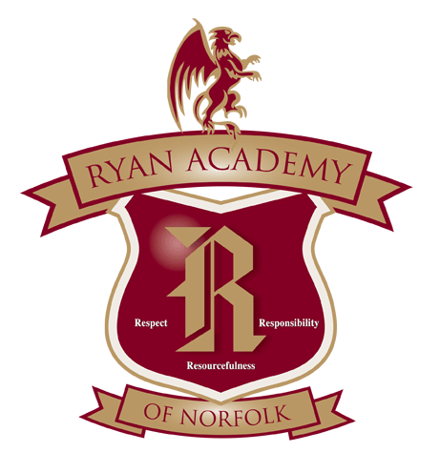

INSPIRED LEARNING

SINCE 1950

RYAN ACADEMY OF

NORFOLK

Date of publication

Ryan Academy is an independent, coeducational day school enrolling students in Kindergarten through grade five. We provide a challenging education which nurtures the intellect and shapes character.
- Safe and structured environment that fosters learning.
- Nurturing environment where self-discipline, self-esteem and personal responsibility are evident.
- Class sizes are small so teachers can truly know and accommodate the students’ needs.
- Foster individual strengths and provide support and encouragement in areas that may be weak.

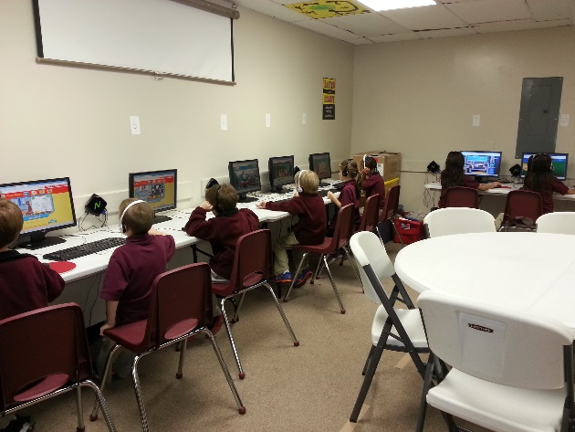

Critical Thinkers-Confident Learners

At the heart of Ryan Academy experience is our progressive core curriculum.
Our core curriculum and its accompanying extra- and co-curricular activities equip every student with the fundamentals to succeed. At the same time, students explore and cultivate their individual talents in a family environment.

Students are honored for their academics, sports, community service, and for exhibiting the tenets of Respect, Responsibility, Resourcefulness, in the classroom, the community, and in extracurricular activities.

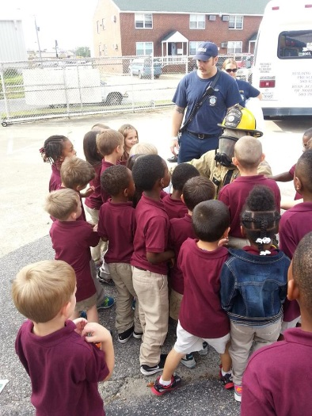

ACADEMICS

Every student in Kindergarten through 5th grades receives instruction each day in literature and composition, mathematics, science, social studies and foreign language. The academic disciplines are complemented by extra- and co-curricular activities.
Technological literacy is an integral part of our curriculum. We educate students on computer use and safety, we employ innovative classroom technology, and we use technology to connect students to the ever-expanding body of knowledge.

Our technology offerings include:
Multiple computer lab equipped with computers, scanners and printers
Several wireless access points throughout the school
Video-conferencing capabilities
Students access to Microsoft 365 accounts.
Ryan Academy
of Norfolk
844 Jerome Ave
Norfolk, VA 23518
Phone (757) 583-7926
www.ryanacademy.org

Company Name
Street Address
Address 2
City, ST ZIP Code
Phone (555)555-0125
Fax (555)555-0145
Web site address

