Spelling Homework Menu 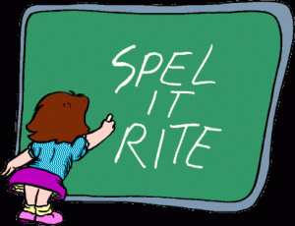

Directions: Get 20 points! Choose as many activities as you need to make 20 points each week. Make sure your words are spelled correctly! Complete each assignment in your homework notebook. Homework will be turned in each Friday morning. Please make sure that you label each assignment with date, title and points. Activities may not be combined, for example, if you write your words in ABC Order one night, you cannot divide that same list into syllables the next night- you MUST write the words again. Remember, the purpose of spelling homework is to learn how to spell your weekly words correctly.

Spelling Homework Choices (20 points due on Friday)

1. Scrambled Words  Write your words. Then write them again with the letters mixed up.  2 points | 2. Word Parts  Write your words. Then use a colored pencil to divide the words into syllables.  2 points | 3. Vowel Spotlight  Write your words using one color for the vowels and another color for the consonants.  (vowels: a, e, i, o, u)  2 points | 4. Rainbow Words  Write your spelling words with colored pencils. Make each word a different color.  3 points
5. Use Technology  Type out your spelling words using different fonts for each word on the computer. Print the words and tape them in your notebook.  3 points | 6. Shape Words  s  s h  s h a  s h a p  s h a p e  5 points | 7. ABC Order  Write all of your spelling words in alphabetical (ABC) order.  5 points | 8. Write each word 3 times each.  Say the word as you spell it.  7 points
9. Picture words  Write each spelling word and draw a picture that represents each word.  7 points | 10. Silly Sentences  Write sentences that use all your spelling words. Underline the words.  8 points | 11. Scrabble  Write spelling words crisscross using a common letter.  Example: same  n  yellow  w  8 points | 12. ” Ransom” Words  Cut letters out of a newspaper or magazine and glue the letters in your notebook to spell your words.  8 points
13. Write a Story, Poem or Song with Words  Write a story using all your spelling words. Underline the words you used.  10 points | 14. Crossword Puzzle  Make a crossword puzzle with your spelling. Show the answers to your puzzle.  10 points | 15. Word Search  Create your own word search with your spelling. Show the answers to your puzzle.  10 points | 16. Question/Answers  Write questions with half of your spelling words. Then use the other half to answer the questions. Underline the words you used.  10 points

